NATIONAL RESTAURANTEXCHANGE

580 Salem Street ste. 12, Wakefield, Ma.01880

(617)721-9655 Fax (781) 246-5000

Broker-Bob Cioffi-Cell 781-820-9288

ma. 01880

LISTING INFORMATION:

LOOK. Prime Location-Turnkey Mediterranean Grille
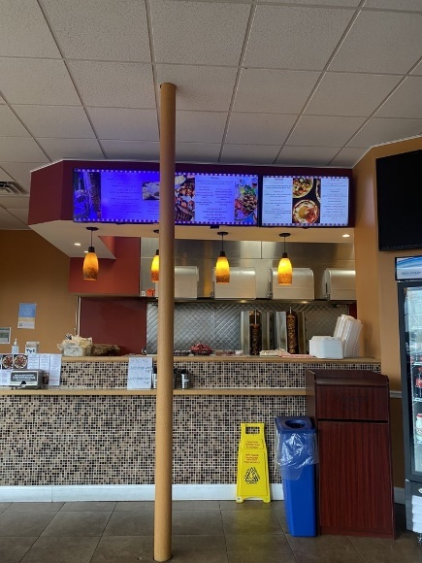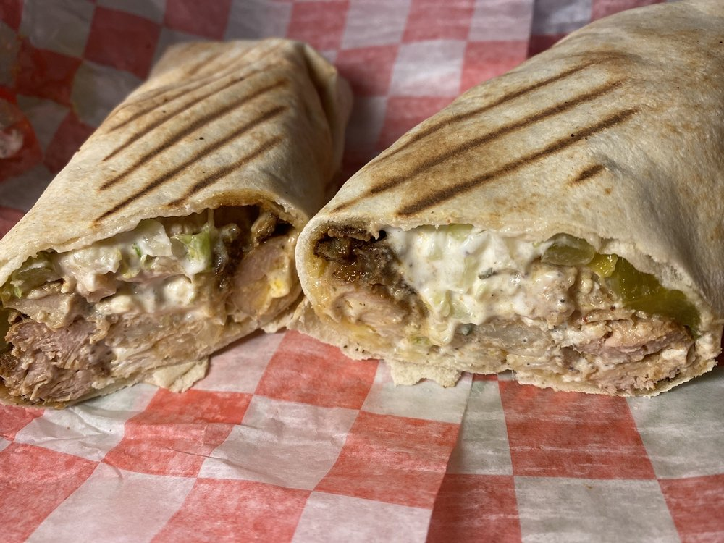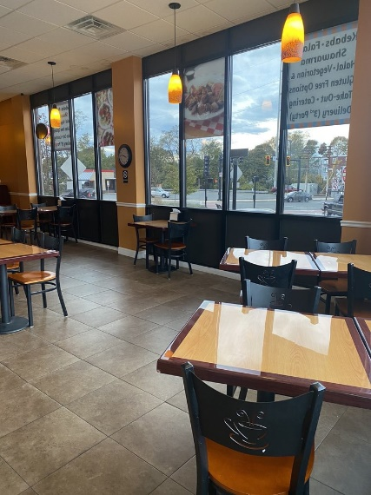

TYPE OF BUSINESS: Prime Location-Turnkey Mediterranean Grille LOCATION: Salem-Beverly Area
SELLING PRICE: $135K. Down payment 100k
SALES VOLUME: $10K wk.
LEASE: $3,825 mt. includes NNN. New lease available.
SQUATRE FOOTAGE: 1,200 sq ft.
HOURS OF OPERATION: 6 days 11am -8pm (9pm, Fri. & Sat) Closed Sundays
SEATING: (inside 25)

COMMENTS: Here’s your chance to own an Authentic middle eastern restaurant. This restaurant gets rave reviews for its fabulous scratch kitchen and service. Homie, warm and offering the tastes of the old world are here for you to enjoy. Turnkey just needs a few employees, a great set up, and easy to operate. Priced to sell with some owner financing if needed. Perfect for a family or an aspiring chef-owner. Has parking & a full cellar. Can also be converted to almost any fast-food concept. Contact Bob @ 781-820-9288 or Bobcioffi14@gmail.com. This will not last, It’s that good.

