NATIONAL RESTAURANT EXCHANGE
(617)721-9655 Fax: (781)246-5000
DSerpone@comcast.net

LISTING INFORMATION

North Shore ROAST BEEF / PIZZA & SEAFOOD
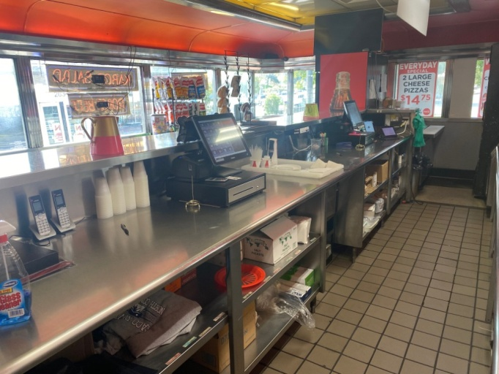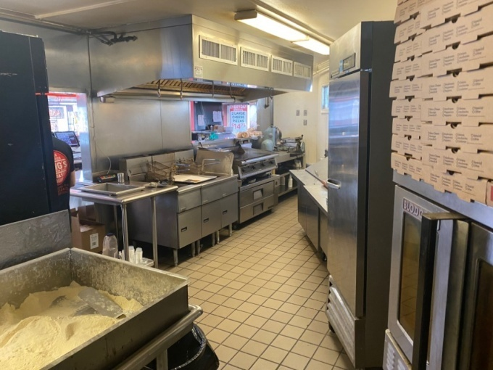

SELLING PRICE: $225,000 with $100K Dn.

SALES VOLUME: $18K - $20K per wk.

LEASE: $3200 a month (includes NNN)

SQUARE FOOTAGE: approximately 1,000 sf.

HOURS OF OPERATION: 7 days…11AM to 10PM

SEATING: 25 seats

REASON FOR SELLING: Over extended with too many restaurants.

COMMENTS: Great landmark operation on Main St, close to the ocean! Great food, nice website, and ordering system in place. Known for its famous Roast Beef & Pizza!
Close in 7 days, no selectman minutes or hearing required. Common VIC same day!
21 nightspots and taverns within walking distance of the store. Huge Anchor stores CVS Dunkin Donuts etc..Call Mr. Williams to be introduced to the owner! 978-715-5405

