NATIONAL RESTAURANT EXCHANGE
(978)715-5405 Fax: (978)-883-3027
nerestaurants@yahoo.com

LISTING INFORMATION

TYPE OF BUSINESS: EXCELLENT NY STYLE PIZZA SHOP
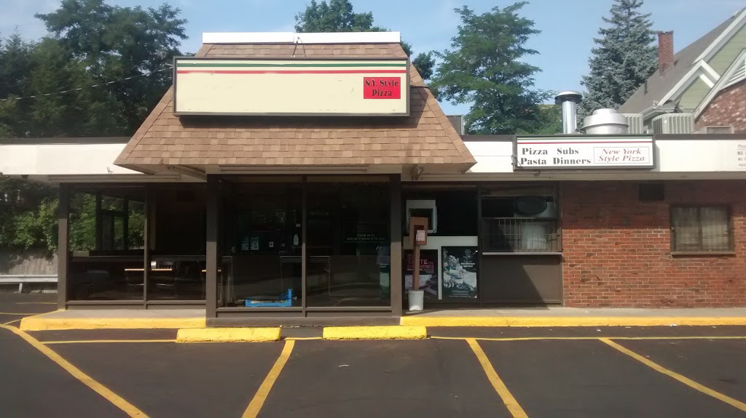
LOCATION: Wakefield area

SELLING PRICE: $189,000 DOWN PAYMENT: only $100,000

SALES VOLUME: strong $14K/wk. % DELIVERY:

LEASE: $3,000/mo. (includes NNN) YRS. LEFT: 3 yrs. New lease available
Awesome landlord

SQUARE FOOTAGE: 2000 SF.

HOURS OF OPERATION: 10-9/ 7 Days

SEATING: inside 34 seats
COMMENTS: Known throughout the region for their New York style pizza, subs, and salads. This is a nice store. Located in a busy section of town. Nice free standing building. Store has 34 seats and is set up for high volume. Current owner is not taking advantage of any social media marketing such as Face Book, Twitter, etc. This location with a seasoned operator can easily do $20K plus a wk. Equipment is all new. Flat top grill, refrigeration, salad units, all under transferable warranty.
Call Mr. Williams @ 978-715-5405 or email nerestaurants@yahoo.com for a private showing.

