NEW ENGLAND RESTAURANT BROKERS
(978-715-5405 Fax: (781)246-5000

LISTING INFORMATION

TYPE OF BUSINESS: GREEK PIZZA
CLOSE TO DOWNTOWN AND COLLEGE
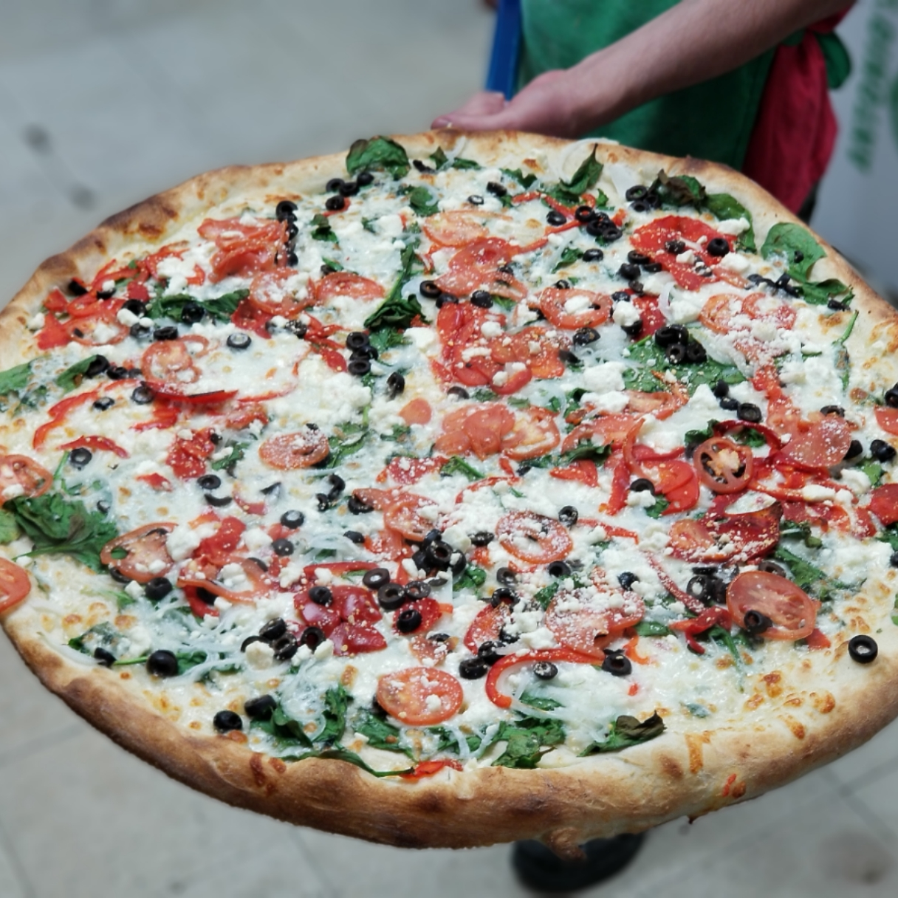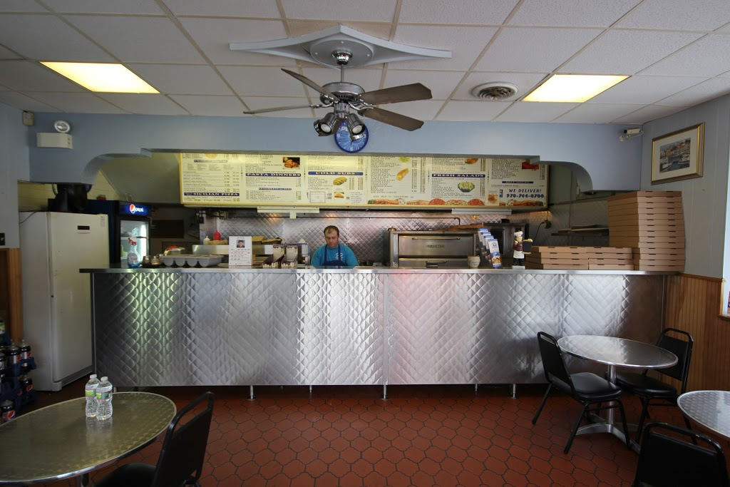

LOCATION: Salem close to downtown and college

SELLING PRICE: $165,000 with $100,000 down

SALES VOLUME: $10K a week

NUMBER OF SEATS: 12 seats outside 4

LEASE: $22000/mo. Includes heat & NNN

YRS. LEFT: New lease available at the same low rent with heat.

SQUARE FOOTAGE: 2,000 SF. incredible basement with private office and storage. Awesome basement. Huge walk-in super clean.
HOURS OF OPERATION: 11:00 AM till 9:00PM 7 days

COMMENTS: This clean and established store is close to down town Salem. It is located close to Salem State College. It has been in business as a Pizza store for 81 years. Nice curbside appeal with 40K car count per day by your front door. Real nice landlord!! Owner is retiring after 20 years. This store can be ramped up easily.
Call Mr. Williams @ 978-715-5405 nerestaurants@yahoo.com

