NATIONAL RESTAURANT EXCHANGE
(617)721-9655 Fax: (781)246-5000
dserpone@comcast.com

LISTING INFORMATION

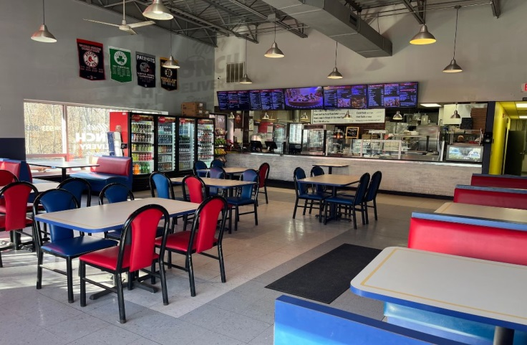
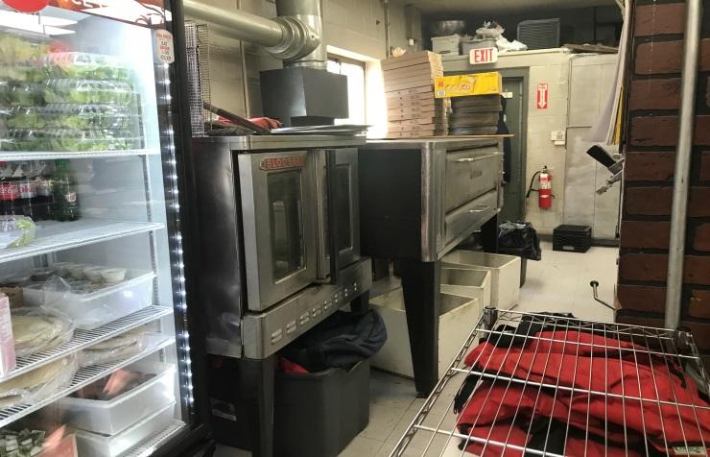
Owner's Cell:___________________________ Owner's email: _____________________________

LOCATION: Woburn / Stoneham Area

TYPE OF BUSINESS: Roast Beef, Pizza & Subs
SELLING PRICE: $ 175,000 DOWN PAYMENT: $75,000

SALES VOLUME: $10,000 /WK Delivery: 10%

LEASE: $4700/mo. (NNN Inc.) YRS. LEFT: New lease at end of current term

SQUARE FOOTAGE: 2500sf

HOURS OF OPERATION: M-F 8 am to 4 pm (closed Sat & Sun)

SEATING: (inside) 40 (outside) 0

REASON FOR SELLING: New Venture
COMMENTS: Want a great looking, well laid out operation, this is it. Very modest rent at $4700/mo. (all Inc.) for end cap on heavily travelled road. In the middle of a huge office park area, with many nationally known companies. Right off of a major interstate, Three years left on the original lease with a new one to be written at end of original term. Add more delivery with third party vendors, and open Sat. Focus more on office and corporate catering and the sky is the limit for short hours. All for the asking price, of $175K and only $75K down.
Don’t wait, won’t last long at this price. !!!
Contact John Ruggieri at 781-858-2343 or jkruggie@comcast.net

